

Case of the stolen szechuan sauce!!



October 5, 2024

lighthouse labs

By: Curtis Crawford

Contents

Investigation Questions and Findings 2

1. What is the Operating System of the Server? 2

2. What is the Operating System of the Desktop? 2

3. What is the local time of the Server? 3

The Server is using **Pacific Standard Time (PST)**. 3

4. **Was there a breach?** 3

5. What was the initial entry vector (how did they get in)? 4

6. Was malware used? If so, what was it? 4

7. Is this malware easily obtained? 7

8. Was this malware installed with persistence on any machine? 7

9. What malicious IP addresses were involved? 7

10. Were any IP addresses from known adversary infrastructure? 7

12. Were these IPs involved in other attacks around the time of the incident? 9

13. Did the attacker access any other systems? How? 9

14. Did the attacker steal or access any data? 10

15. What was the network layout of the victim network? 10

16. What architecture changes should be made immediately? 10

17. Did the attacker steal the Szechuan sauce? If so, what time? 10

18. Did the attacker steal or access any other sensitive files? If so, what times? 11

References 13

# Investigation Questions and Findings

## What is the Operating System of the Server?

* + A screenshot of a computer

    Description automatically generatedThe Operating System of the Server is **Windows Server 2012 R2 Standard Evaluation**.

## What is the Operating System of the Desktop?

* 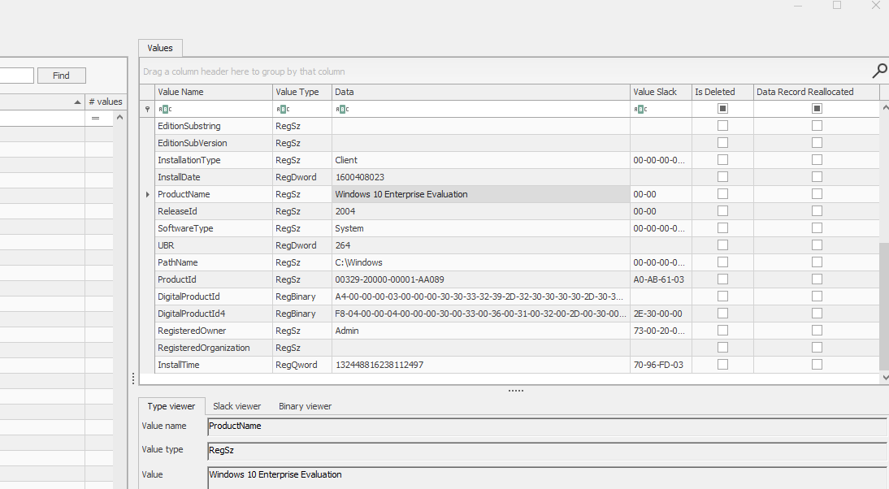The Operating System of the Desktop is **Windows 10 Enterprise Evaluation**.

## What is the local time of the Server?

## The Server is using **Pacific Standard Time (PST)**.

## **Was there a breach?**

* + **Yes**, the following details outline the reasons for confirming this breach.

## What was the initial entry vector (how did they get in)?

* + 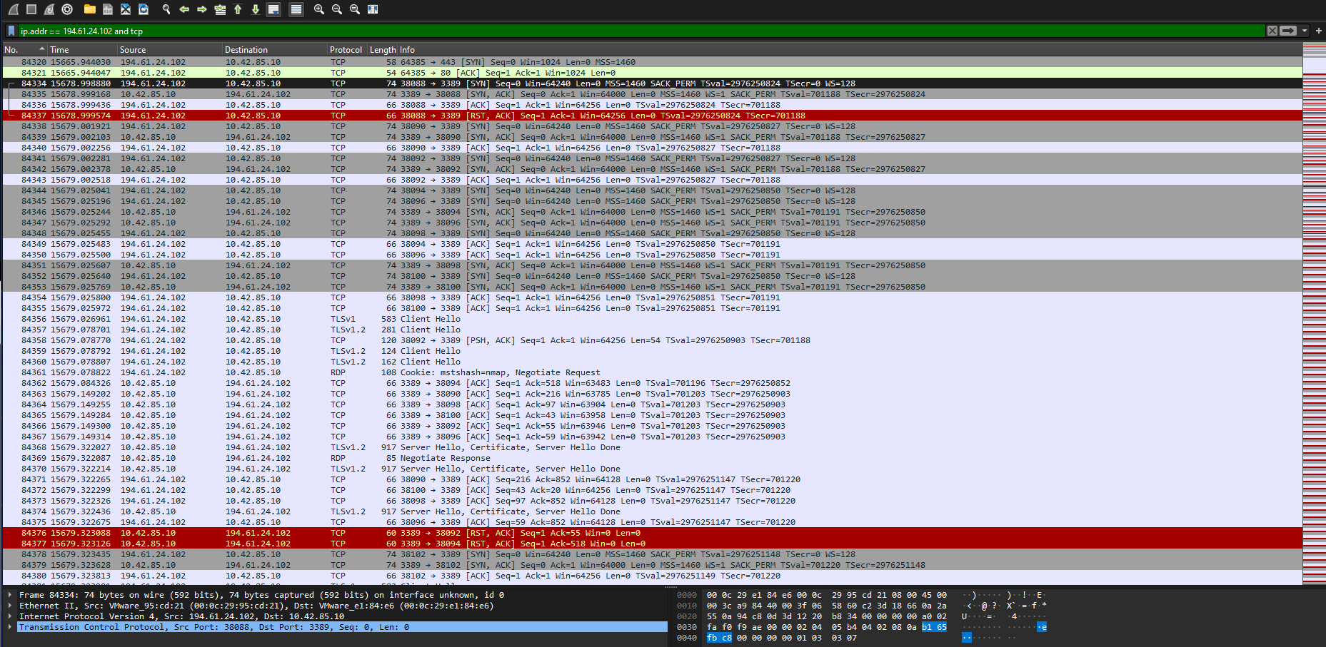The attacker used a **Brute Force Attack**, evident by multiple SYN requests targeting the same destination source.

## 6. Was malware used? If so, what was it?

**A) What process was malicious?**

* + A screenshot of a black screen

    Description automatically generated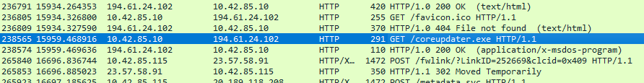The malicious process was **coreupdater.exe**. The IP address 194.61.24.102 was identified as malicious. Filtering its activities in the pcap file led to a GET request for coreupdater.exe, which after being exported and tested, was flagged as a Trojan by Windows Defender.

**B) Identify the IP Address that delivered the payload.**

* + The payload was delivered from **194.61.24.102**.

**C) What IP Address is the malware calling to?**

* + Using Volatility's Netscan, the malware was calling **203.78.103.109:443**.

**D) Where is the malware located on disk?**

* + 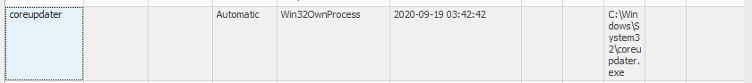The malware was located at **C:\Windows\System32\coreupdater.exe**, as seen in the AutoRunsc-Citadel-DC01.csv file.

**E) When did the malware first appear?**

* + A screen shot of a black screen

    Description automatically generatedIt first appeared on **2020-09-19 at 03:56:37 UTC+0000**, as identified by the pslist command in Volatility.

**F) Was the malware moved?**

* + Yes, since it was found in **C:\Windows\System32**, it indicates that the file was moved from its usual download location.

1. **What were the capabilities of this malware?**
   * A screenshot of a computer

     Description automatically generatedThe malware is categorized as **Metasploit**, which is a tool used for penetration testing, patch testing, and security engineering. In malicious hands, it can inflict significant damage to a system.

## Is this malware easily obtained?

* + **Yes**, Metasploit can be downloaded from multiple sources online, including a simple Google search.

## Was this malware installed with persistence on any machine?

* + **Yes**, the malware is set to start automatically.  
    **When?** *2020-09-19 03:42:42*  
    **Where?** *C:\Windows\System32\coreupdater.exe*

## What malicious IP addresses were involved?

* As shown in the previous answers and pictures, the malicious IP addresses were **194.61.24.102** (Russia) and **203.78.103.109** (Thailand).

10. Were any IP addresses from known adversary infrastructure?

* **Yes**, 194.61.24.102 (Russia) is flagged for RDP and spam attacks, while 203.78.103.109 (Thailand) has a few suspicious flags on VirusTotal as shown in the pictures on the next page.

**  
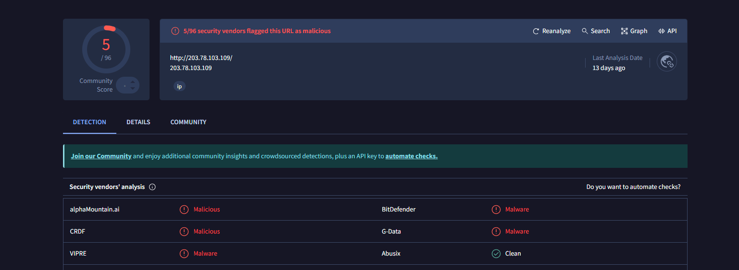**

## 12. Were these IPs involved in other attacks around the time of the incident?

* **Yes**, as shown in previous answers, these IP addresses were linked to other attacks.

## 13. Did the attacker access any other systems? How?

* **A screenshot of a computer

  Description automatically generatedYes**, the attacker accessed the system **Desktop-SDN1RPT$** via an RDP connection, as shown in the case001.pcap file in Wireshark.  
  **When?** *2020-09-18 22:21:26*

## 14. Did the attacker steal or access any data?

* 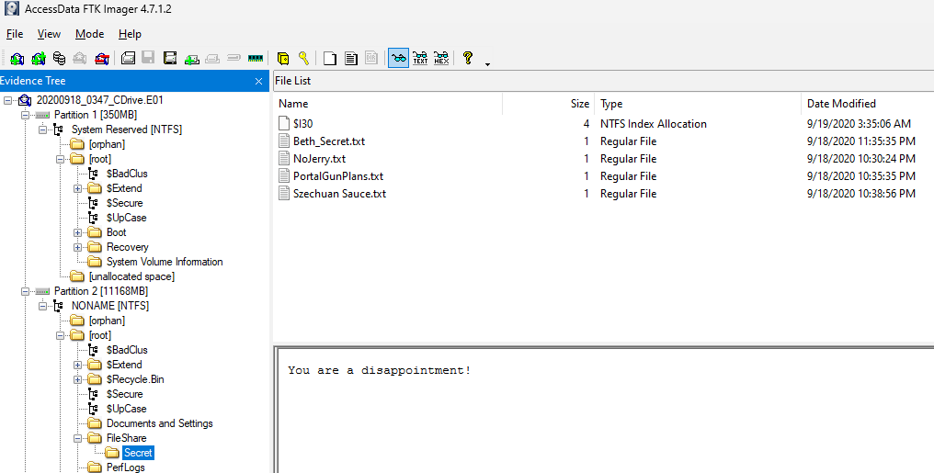**Yes**, the files in the "Secret" folder were accessed. This was viewed in FTK Imager.  
  **When?** *2020-09-18*

## 15. What was the network layout of the victim network?

* The network consists of a Domain Controller and a Desktop:  
  *Citadel-DC01* >>> *Desktop-SDN1RPT*

## 16. What architecture changes should be made immediately?

* **Limit RDP access** to the Domain Controller and restrict it to local network users only.

## 17. Did the attacker steal the Szechuan sauce? If so, what time?

* **Yes**, the Szechuan Sauce was stolen on **2020-09-18 at 18:35:59**, as shown in Autopsy.  
    
  *A screenshot of a computer

  Description automatically generated*

## 18. Did the attacker steal or access any other sensitive files? If so, what times?

* 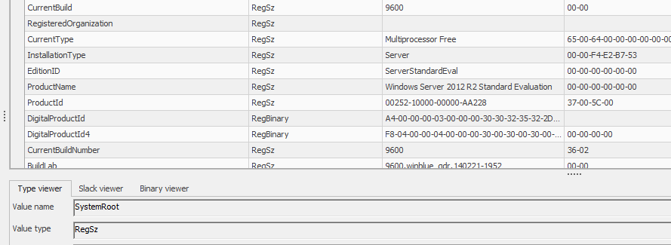**Yes**, the **SECRET_Beth** file was accessed on **2020-09-18 at 18:39:22** and deleted at **23:24:27** the same day. A new file, **Beth_Secret**, was created less than a minute later at **23:25:07**.

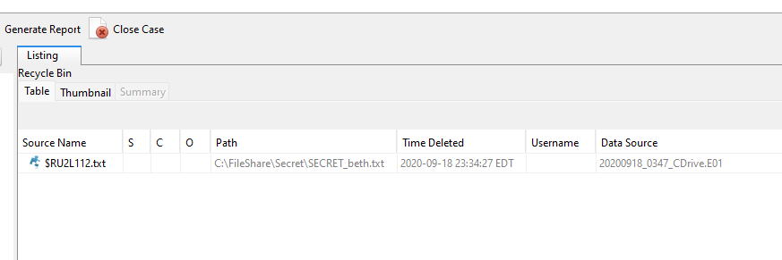

**Summary of Key Findings**

The investigation which was led by Shannah Everitt and executed by Curtis Crawford has revealed a sophisticated breach involving a brute force attack, malware installation (coreupdater.exe), and RDP exploitation. The attacker accessed sensitive files and moved malware to a non-standard location. Shannah directed and discussed with Curtis on where to look and what to look for while Curtis oversaw controlling the VM and taking pictures as evidence.

# References

Comparitech. (2019, June). **Wireshark cheat sheet**. <https://cdn.comparitech.com/wp-content/uploads/2019/06/Wireshark-Cheat-Sheet.pdf>

CleanTalk. (n.d.). **Blacklist: 194.61.24.102**. CleanTalk. <https://cleantalk.org/blacklists/194.61.24.102>

CleanTalk. (n.d.). **Blacklist: 203.78.103.109**. CleanTalk. <https://cleantalk.org/blacklists/203.78.103.109?show_api=1#owner>

Criminal IP. (n.d.). **IP report: 194.61.24.102**. Criminal IP. <https://www.criminalip.io/asset/report/194.61.24.102>

Joe Sandbox. (n.d.). **Analysis report: 194.61.24.102**. Joe Sandbox. <https://www.joesandbox.com/analysis/1391302/0/html>

Tenable. (n.d.). **Plugin: 30**. Tenable Network Security. <https://www.tenable.com/plugins/nnm/30>

VirusTotal. (n.d.). **IP address report: 194.61.24.102**. VirusTotal. <https://www.virustotal.com/gui/ip-address/194.61.24.102>

Veterans Affairs Office of Information and Technology. (n.d.). **Registry Explorer manual**. <https://www.oit.va.gov/Services/TRM/files/RegistryExplorerManual.pdf>

Sleuth Kit. (n.d.). **Autopsy 4.0 user documentation**. <https://sleuthkit.org/autopsy/docs/user-docs/4.0/>